Graphics PICtail Plus Board Memory Programmer

This programmer allows downloading Intel Hex file into memory installed on Graphics PICtail Plus Board. It consists of 2 parts: Explorer 16 Board side (prg.hex) and PC side (prg.exe). PC transmits Hex file to Explorer 16 Board through UART and Explorer 16 programs flash memory installed on Graphics PICtail Board using PMP.

PC
PRG.EXE
Explorer 16 Board
PRG.HEX
Graphics PICtail Plus Board
FLASH MEMORY
UART
PMP

To program flash memory on Graphics PICTail following steps must be done:

- Connect Explorer 16 to PC with RS232 cable.
- Attach Graphics PICtail Plus Board to Explorer 16 with expansion connector J9.
- Program Explorer 16 board with prg.hex.
- Erase previous data in the memory. To do this on Explorer 16 while holding S3 button press and release MCLR. LEDs must light indicating the erasing is in progress. In a few second they must become off. After this the memory is erased and ready for a new programming cycle.
- Run prg.exe utility.

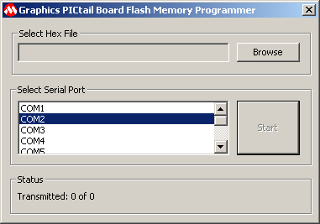

- Press “Browse” button and select intel hex file to be programmed.
- Select COM port connected to Explorer 16 board and press “Start” button.

